**Project Proposal**

##Project Title:

* SkillMatch (Teacher Assistant)

##Short description for project idea:

* "SkillMatch is an innovative platform that connects educators with talented students eager to assist in the learning process. Students can create profiles to showcase their skills, making it easy for teachers to find the perfect teaching assistants. This collaborative platform streamlines the education experience, fostering a dynamic learning environment for all."

##Merits and demerits:

* **Merits (Advantages):**

1. Efficient Matching:

* It efficiently matches teachers with students possessing relevant skills, saving time and effort in the recruitment process.

1. Skill Development:

* Students can enhance their skills while assisting teachers, gaining valuable experience for their future careers.

1. Cost-Effective:

* Offers a cost-effective alternative to hiring full-time teaching assistants or tutors.

1. Enhanced Learning:

* Provides students with opportunities for hands-on learning and real-world application of their skills.

1. Flexibility:

* Offers flexibility for both teachers and students in terms of scheduling and commitments.

1. Diverse Talent Pool:

* Allows teachers to tap into a diverse pool of student expertise, potentially covering a wide range of subjects and skills.
* **Demerits (Disadvantages):**

1. Quality Control:

* Ensuring the quality of student assistance may be challenging, as there may be variations in skill levels and dedication.

1. Data Privacy:

* Handling student profiles and teacher information requires robust data privacy and security measures to protect sensitive data.

1. Limited Availability:

* The availability of skilled students may vary which could lead to a shortage of suitable assistants during peak times.

1. Technical Challenges:

* Developing and maintaining the platform can be technically complex and require continuous updates and support.

1. Misuse:

* There may be cases of students misrepresenting their skills or teachers misusing the platform for purposes other than education.

1. Competition:

* Depending on the platform's success, it may face competition from other similar services or educational institutions offering their solutions.

##Language's need for develop this project:

* HTML, CSS(Bootstrap), JavaScript, MySQL, Python(Django) / PHP(Laravel).

##**Some demo Picture of our App/Site:**

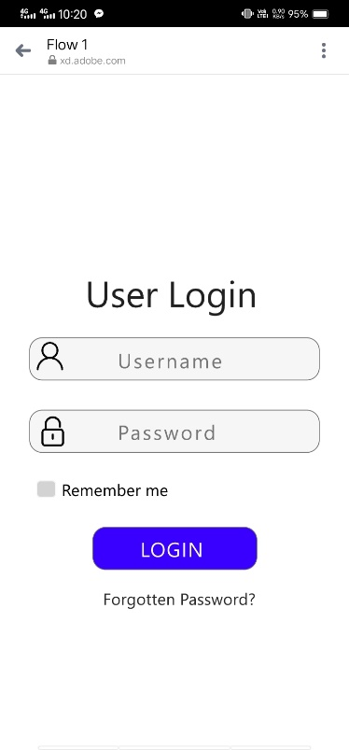 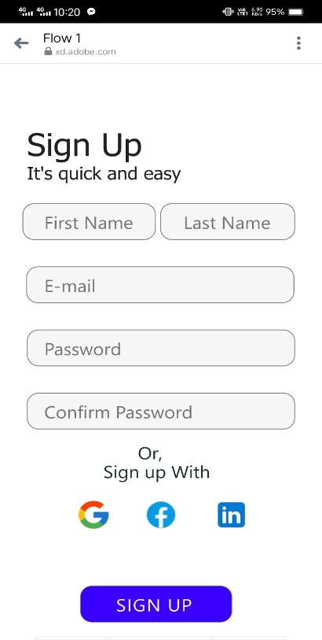 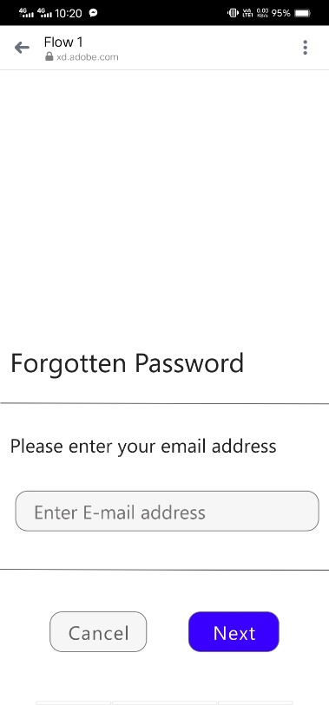 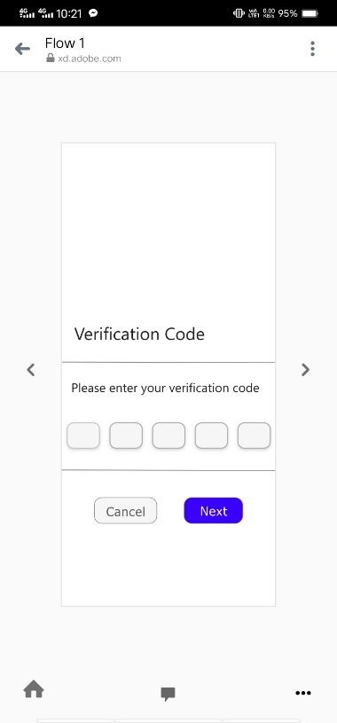 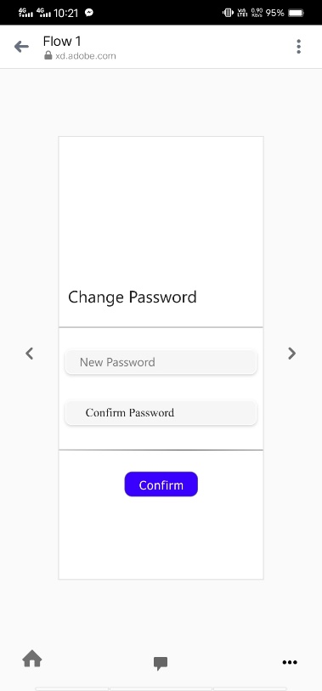 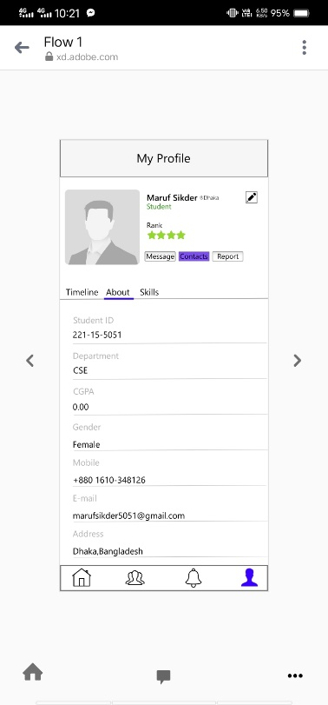

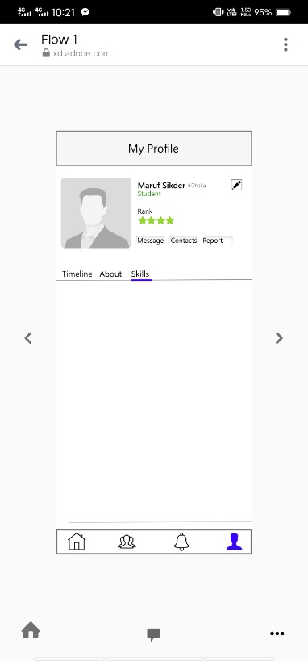 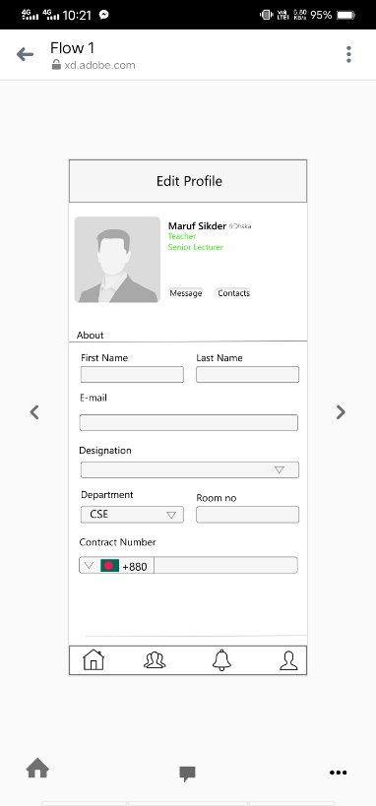 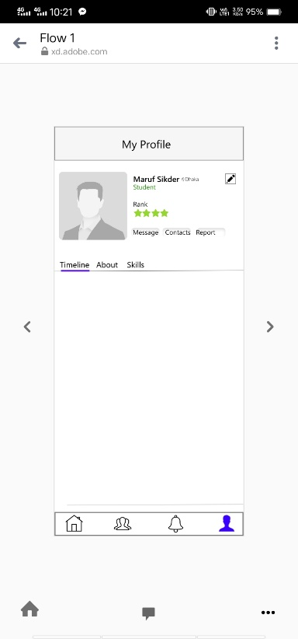 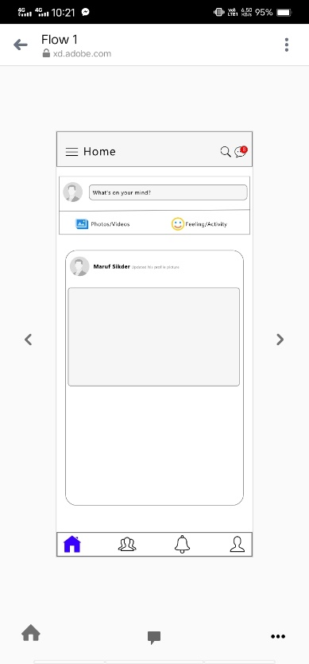 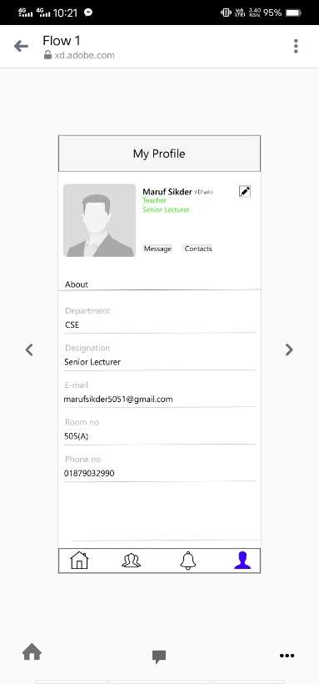 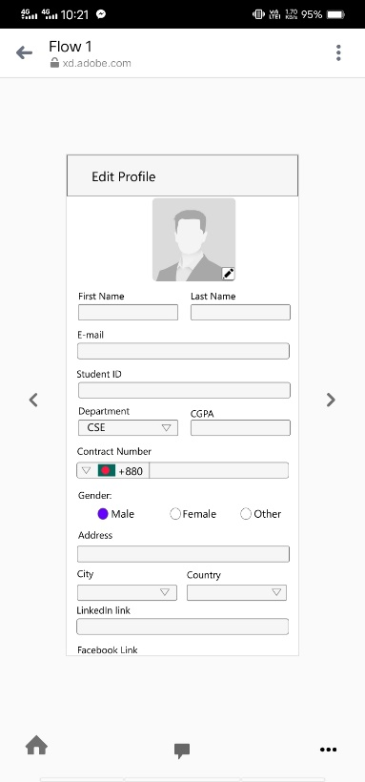

**##If you want to see our full pototype link, click the above link:**

**https://xd.adobe.com/view/8539ec56-660b-42c6-82b3-747d3e9361a4-d06a/**